Unit5 Thumbnail Sketches –

Michael Friedman

**Home**

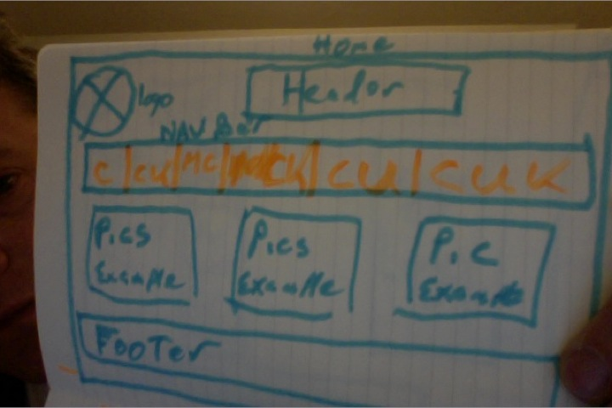

Focal point: The Picture Examples will be the main focus, with examples from each Group (Couples, Couples with Kids, Married Couples, Married Couples with Kids, Civil Unions and Civil Unions with Kids option Brady Bunch Category). I just illustrated Couples, but the other 2 will be the same. Underneath each will be a drop down navigation to choose which generation you would like to search. The **Greatest Generation, Boomers, Generation X, Generation Y, and Millennials.**

Hierarchy: The Nav Bar will be able to guide you to your destination to click on. The Home page should not be that cluttered with items. It should be simple. The Header will have a short simple explanation of the site.

Balance: There will be a balance between the Picture Examples and the Nav Bar. The Pictures will be balanced, so you can be guided to the item you want to click on.

**About**

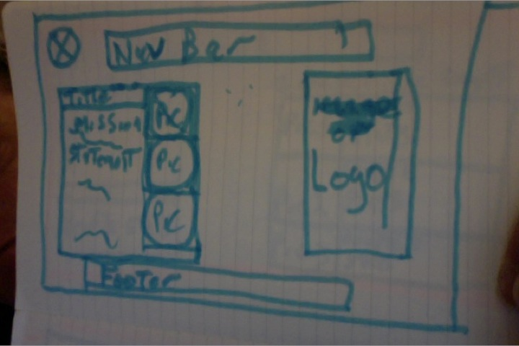

Focal point: The Mission Statement with Pictures of Directors will be the main Focal point.

Hierarchy: The Nav Bar will provide the ability to go where you want, with the simple mission statement and

Balance: The Mission Statement and Logo will provide balance with each other.

**Couples:**

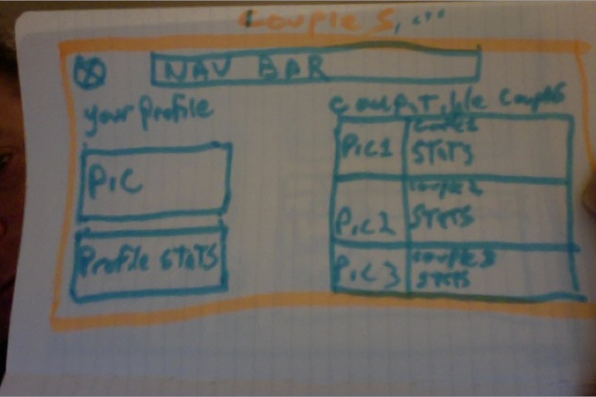

Focal point: The Compatible Couples will have a bigger Headline and take up more space, then the Your Profile and Stats box. This is not to scale. You will be able to click on the Picture for the Compatible Couples for more details.

Hierarchy: the elements will be simple with the Nav bar being consistent across all pages, and the Compatible Couples having more prominence than the Your Profile section.

Balance: There will be a balance between your profile (which will be smaller) and the Compatible Couples with the 3 different choices, and a more button to scroll thru more couples. 3 at a time is the best grouping, I think, so you are not over whelmed with choices.

**Couples – Detail:**

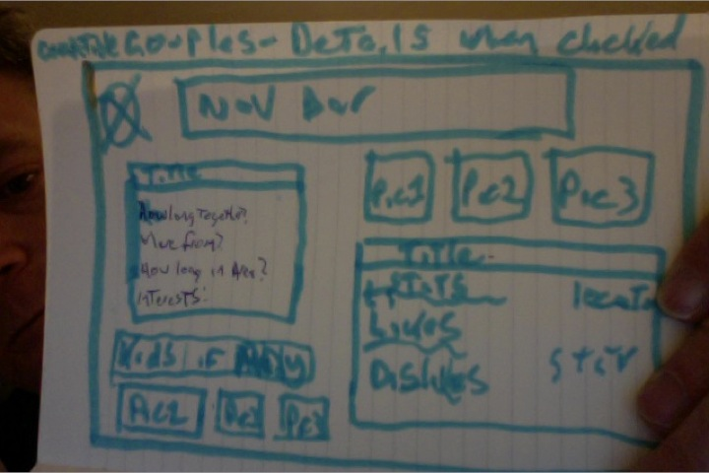

Focal point: There will be no one focal point. The Details page will be split between the Title and stats on the Left, and the Title and stats on the right, with the Pictures helping to provide more visual stimulation.

Hierarchy: There hierarchy is for the 2 main Title/statistics windows, with the pictures sub-heading or preceding both to make your brain think.

Balance: The Kids Pictures will be smaller than the Pictures on the top right, so the top right pictures of the Couples detail being chosen will be more prominent, so the kids pictures do not distract from the original goal of finding compatible couples first.